ASSIGNMENT-7.4
NAME :B.Jahnavi
Roll No : 2403A52167
Batch : 07
Task Description #1:
• Introduce a buggy Python function that calculates the factorial of a number using recursion.
Use Copilot or Cursor AI to detect and fix the logical or syntax errors.
Expected Outcome #1:
• Copilot or Cursor AI correctly identifies missing base condition or incorrect recursive call and
suggests a functional factorial implementation
PROMPT:
Give me a buggy python code that calculates the factorial of a number using recursions and i need to identify the error.
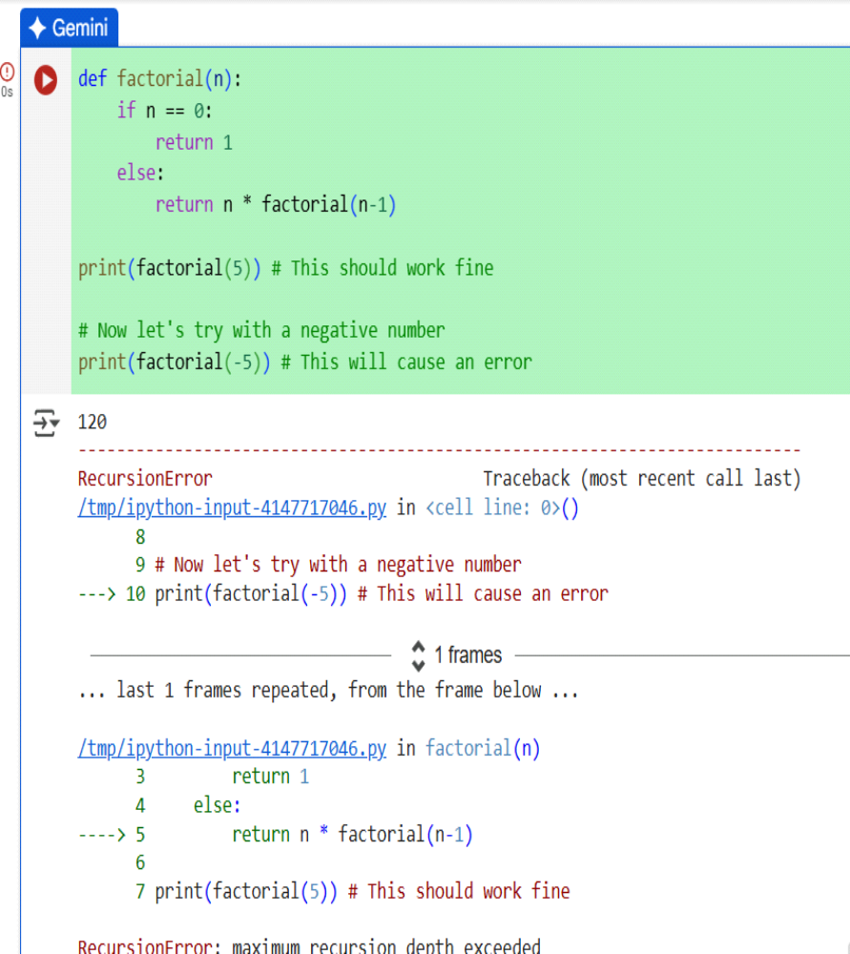

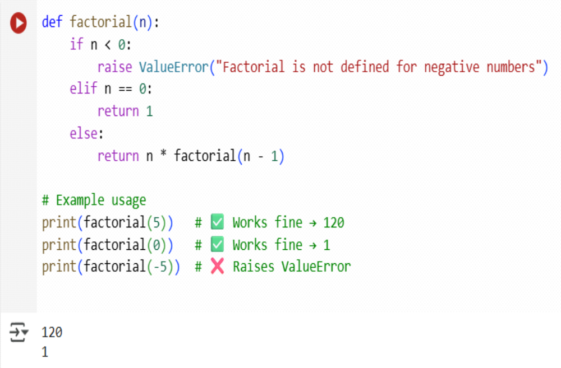
Task Description #2:
• Provide a list sorting function that fails due to a type error (e.g., sorting list with mixed
integers and strings). Prompt AI to detect the issue and fix the code for consistent sorting.
Expected Outcome #2:
• AI detects the type inconsistency and either filters or converts list elements, ensuring
successful sorting without a crash.
PROMPT:
Wrote a function to sort a list, but it fails with a TypeError because the list has both integers and strings. Can you explain the issue and rewrite the function so it sorts the list consistently.
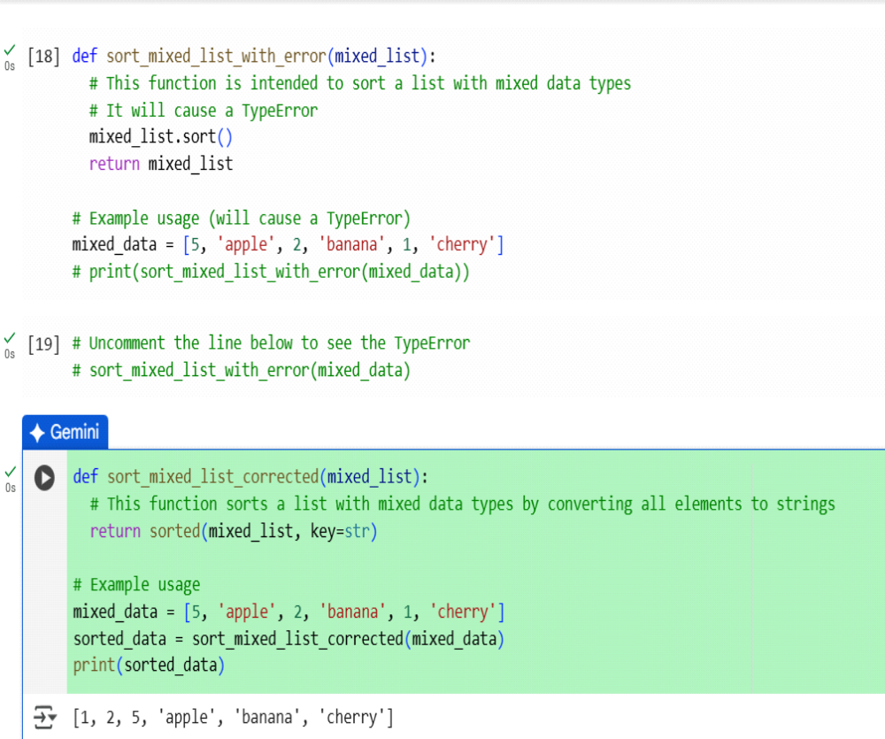

Task Description #3:
• Write a Python snippet for file handling that opens a file but forgets to close it. Ask Copilot or
Cursor AI to improve it using the best practice (e.g., with open() block).
Expected Outcome #3:
• AI refactors the code to use a context manager, preventing resource leakage and runtime
warnings.
PROMPT:
I wrote a Python snippet that opens a file but I forgot to close it. Can you refactor it using best practices like a context manager (with open) to avoid resource leaks
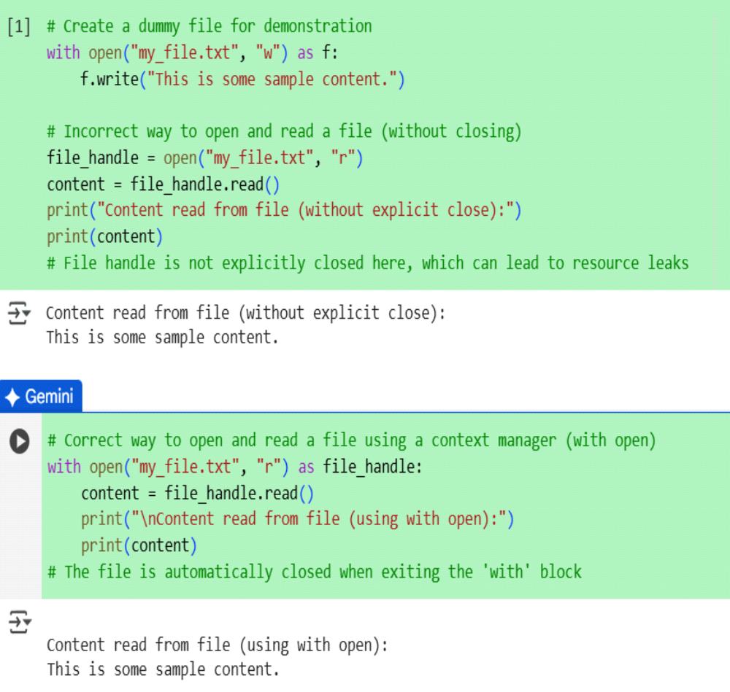

Task Description #4:
• Provide a piece of code with a ZeroDivisionError inside a loop. Ask AI to add error handling
using try-except and continue execution safely.
Expected Outcome #4:
• Copilot adds a try-except block around the risky operation, preventing crashes and printing a
meaningful error message.
PROMPT:
I wrote a loop in Python that causes a ZeroDivisionError. Can you add try-except so it handles the error and keeps running safely
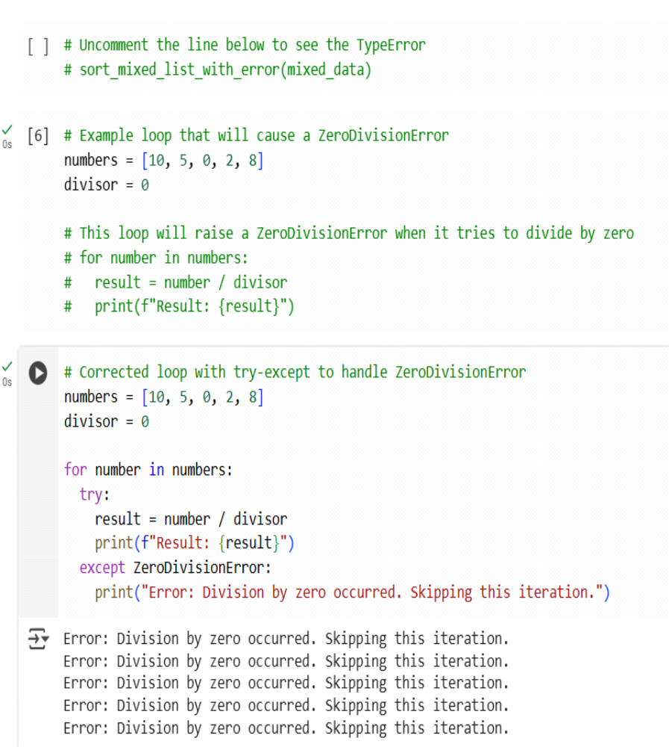

Task Description #5:
• Include a buggy class definition with incorrect __init__ parameters or attribute references. Ask
AI to analyze and correct the constructor and attribute usage.
Expected Outcome #5:
• Copilot identifies mismatched parameters or missing self references and rewrites the class with
accurate initialization and usage
PROMPT:
I wrote a Python class with mistakes in the __init__ method and attribute references. Can you fix the constructor and correct the attribute usage
